Front Reflector Bracket Installation
This section covers several different placements of the front reflector bracket. Make sure the front reflector is vertical (perpendicular to the ground).
The front reflector bracket will mount on the fork or handlebar. If the reflector is not installed, refer to the ‘Front Reflector Bracket and Clear Reflector Assembly” section.
Determine which type of reflector bracket you have and its mounting location and then follow the instructions for that style.
Top of Fork Bottom of Fork Handlebar Mount Handlebar Mount
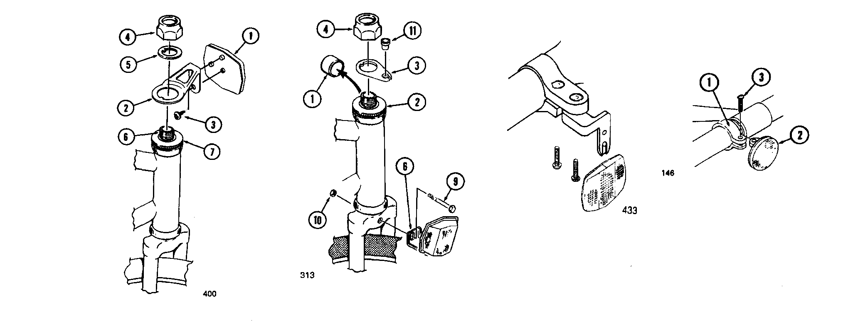

Top of Fork
1. Attach the hardware to the fork:
- Remove and discard plastic cap (if installed) on fork.
- Tighten bearing cone by hand to make sure the bearings are tight.
- Install reflector bracket and locknut.
- Tighten the locknut.

Bottom of Fork
- Attach the hardware to the fork:
- Remove and discard plastic cap (if installed) on fork.
- Tighten bearing cone by hand to make sure the bearings are tight.
- Install the keyed washer and locknut.
- Tighten the locknut.
- Assemble the front reflector bracket and reflector to the fork:
- Attach the reflector bracket to the front of the fork with a bolt and locknut.
- Adjust the angle of the reflector bracket as needed.

